PRACTICAL-12

JK Enterprises wants to have an Auditor account in IBM Security Identity Manager to manage auditing. Organization wants auditors to have access to audit information about computers and application access in order to determine the level of compliance with company and regulatory policies.

Organization also wants to create a custom report that generates an email list from the data that is stored in IBM Security Identity Manager.

**Auditing in IAM.**

Internal auditors play an important role in helping organizations to develop effective IAM processes and monitor their implementation. Prior to conducting an IAM audit, auditors need to understand the organization’s existing IAM structure, such as the company’s business architecture and IAM policies, as well as the laws, regulations, and mandates for which compliance is necessary. When conducting the audit, internal auditors need to document the organization’s identity and entitlement processes — as well as the repositories and the life cycle components for each — and evaluate existing IAM activity controls.

**Tasks to be done:**

1. Creating a User Account (Doctor Strange) and Setting Password.
2. Configuring an IBM Security Identity Manager Auditor account
3. Run Data Synchronization to update reporting data
4. Running reports
5. Creating a custom report in the Report Designer

**Implementation:**

**Creating User Account (Doctor Strange) and Setting Password**

1. On the Home tab, you go to Manage Users.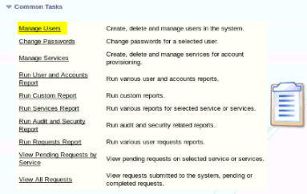
2. Add new user Doctor Strange.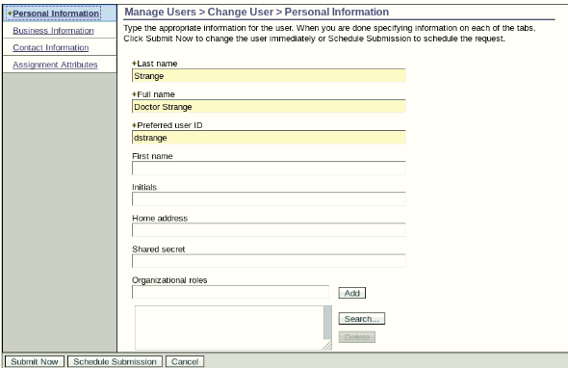

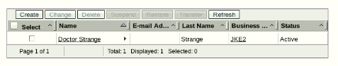

1. Set password for the user as P@ssw0rd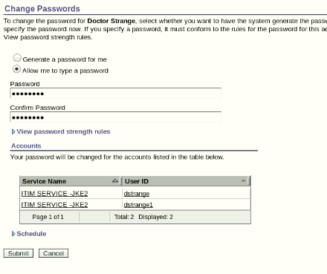

**Configuring an IBM Security Identity Manager Auditor account**

1. On the Home tab, you go to Manage Groups. Search for ITIM Service, select it,and click Continue.

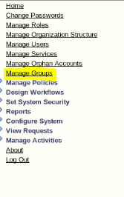

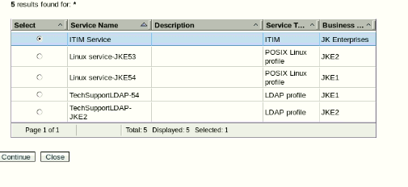

1. Click Refresh to show all the groups.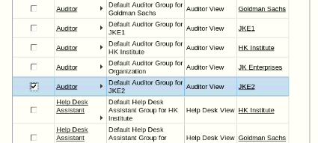
2. Click the small triangle to the right of Auditor and choose Add Members

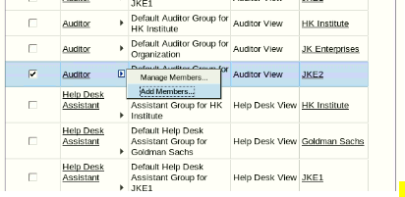

1. Click Add. Search for Doctor Strange and add him to the group.

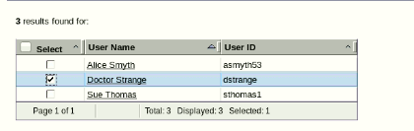

1. Submit the request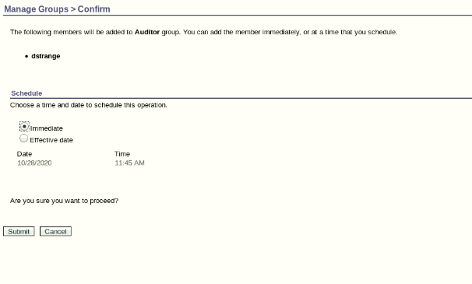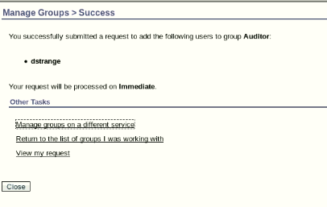
2. Log out of the IBM Security Identity Manager Administrative Console and log back in as the auditor, dstrange with password P@ssw0rd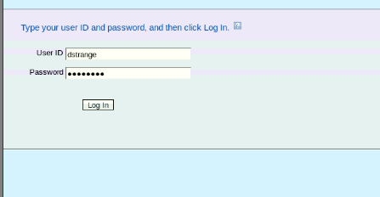
3. Notice the auditing and reporting functions listed under Common Tasks on the home page: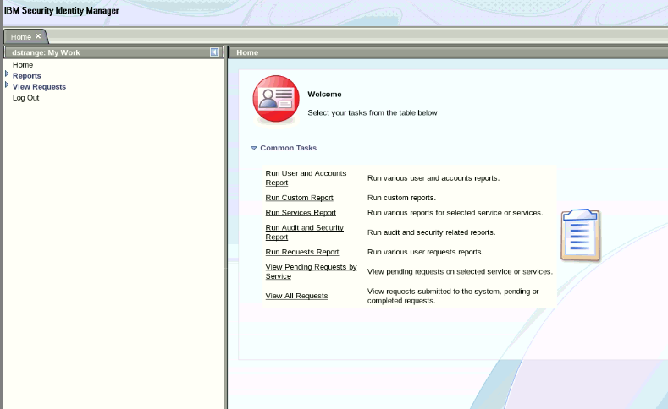

**Run Data Synchronization to update reporting data**

1. Log in to the IBM Security Identity Manager Administrative Console with ISIM Manager.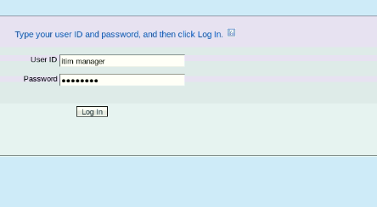
2. On the Home tab, go to Reports > Data Synchronization.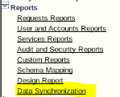
3. Click Run synchronization now. Click Run.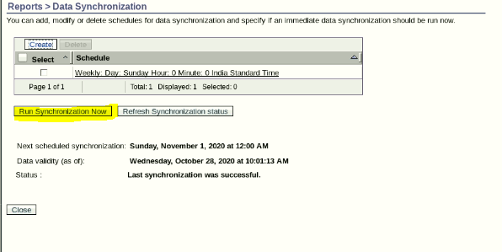

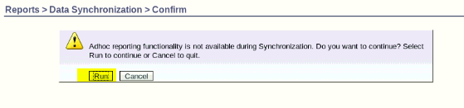

1. Return to the Data Synchronization tab. Create a weekly run occurring on Friday at 12:00 AM.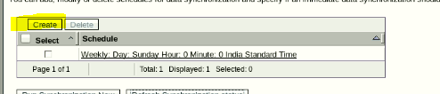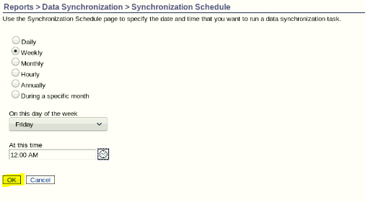
2. Return to the Data Synchronization tab and click Refresh Synchronization Status. Confirm that you see a successful status message. It takes a couple of minutes.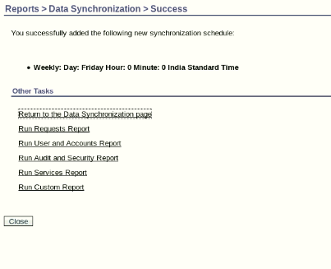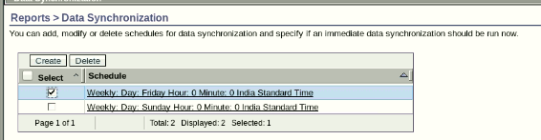
3. Log out.

**Running reports**

1. Log in to the IBM Security Identity Manager Administrative Console as auditor Doctor Strange with user ID dstrange.
2. On the Home tab, go to Reports.

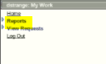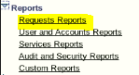

1. Look through the different reporting sections and run the following reports: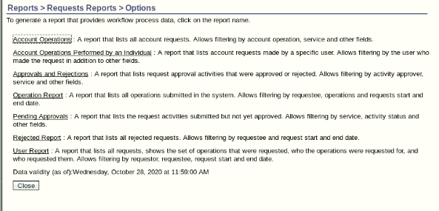
   1. Account Operation Report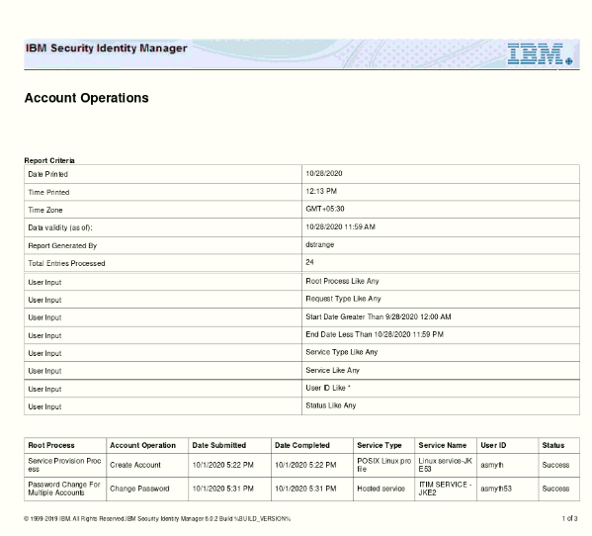
   2. Account Operation Performed by an Individual Report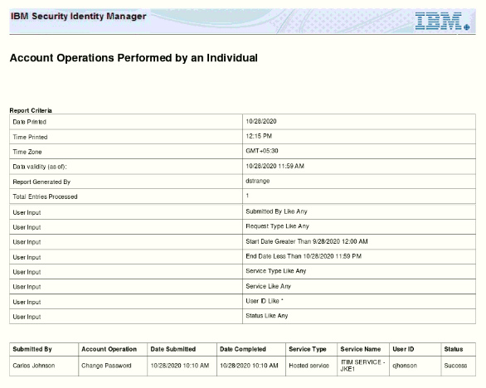
   3. Approval and Rejections Report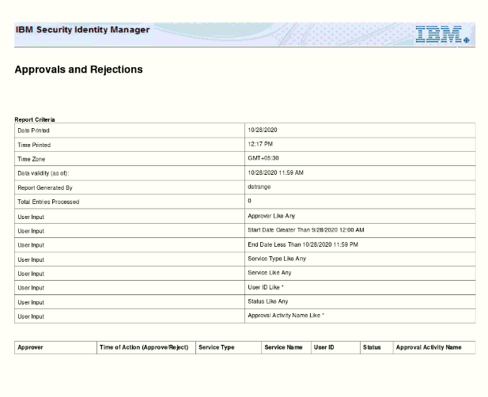
   4. Operations Report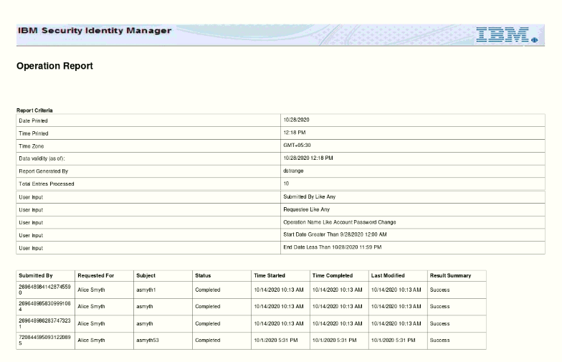
   5. Users Report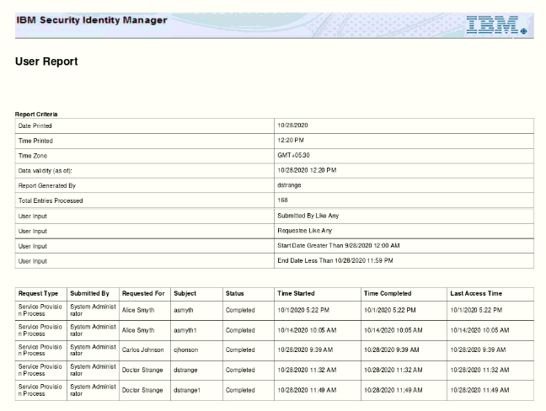

**Creating a custom report in the Report Designer**

1. Log in to the IBM Security Identity Manager Administrative Console with ISIM manager.
2. On the Home tab, go to Reports >Schema Mapping.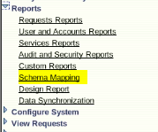
3. Select Person* from the Entities drop-down menu.Select the email address attribute from the Unmapped Attributes list.Map it by clicking Add to move it into the Mapped Attribute list.

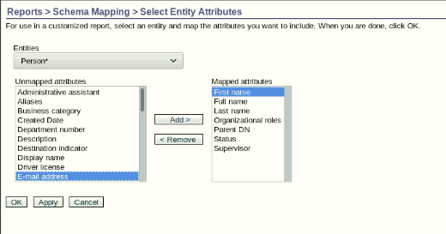

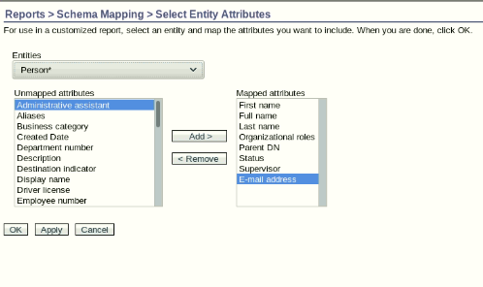

1. Click OK.

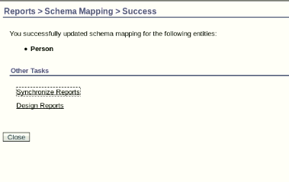

1. On the Home tab, go to Reports >Data Synchronization. Click Run Synchronization Now.

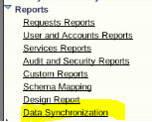

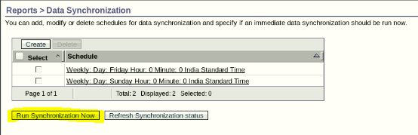

1. Wait until the data synchronization completes before proceeding.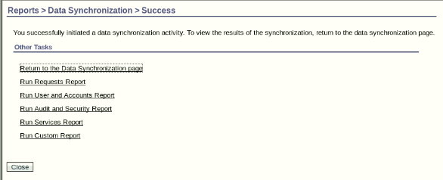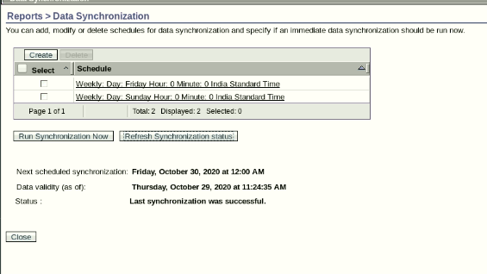
2. On the Home tab, go to Reports > Design Report.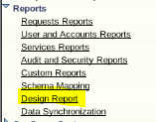
3. You create a new report with the information in the following table: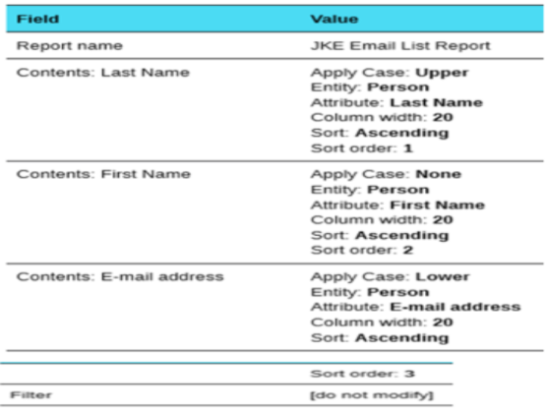

Note: Use the upper function to show the data in uppercase and the lower function to show the data in lowercase.

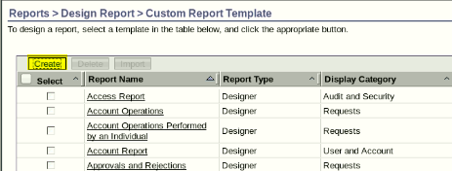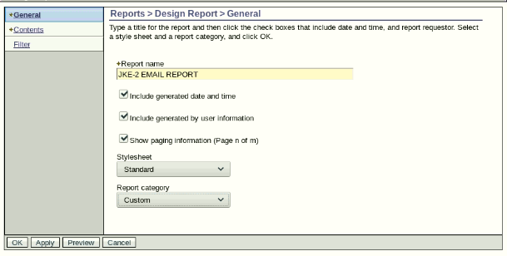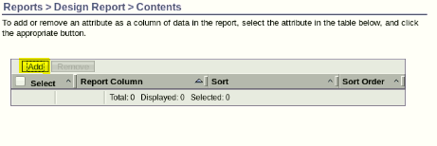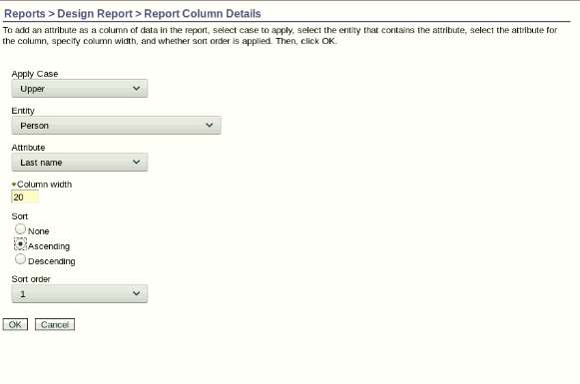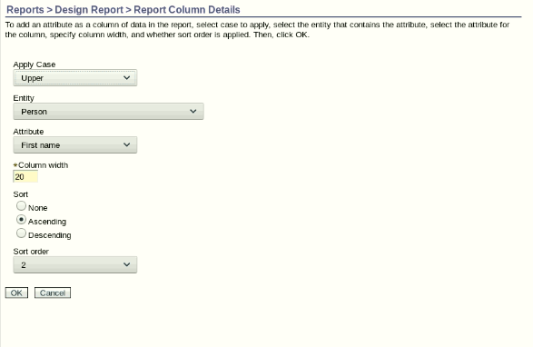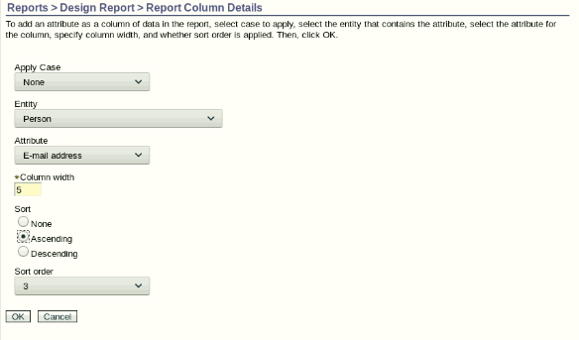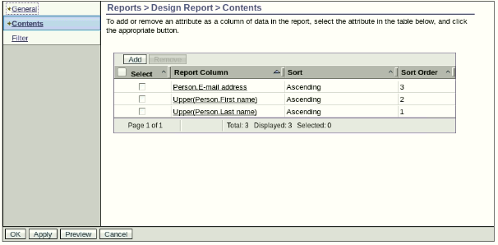

1. Click OK to submit the new report.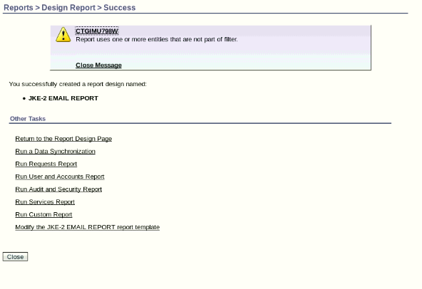
2. On the Home tab, go to Reports >Custom Reports. Run your newly created report and confirm values are as you expect. Download using PDF format and view.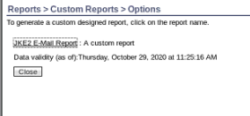

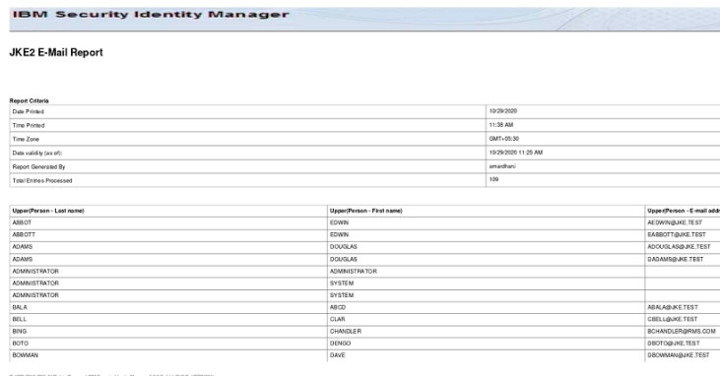

Conclusion:

By implementing the above scenario we are able to understand the basic working of Auditing in IAM systems and the importance of the auditing .